**USER INTERFACE**

1. **USER INTERFACE**

**ADMIN LOGIN**

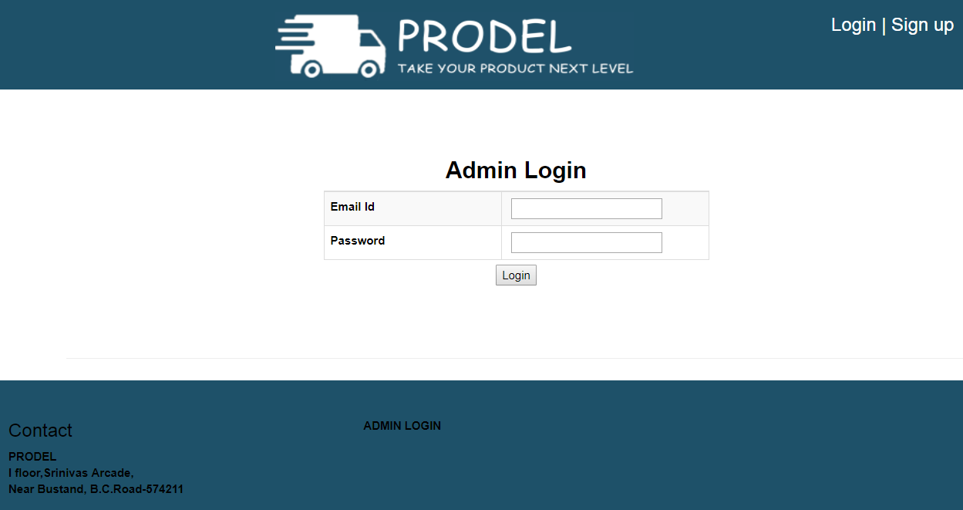

This is the customer Login page. Customer can Login by using username and password to purchase any products.

**ADMIN DASHBOARD**

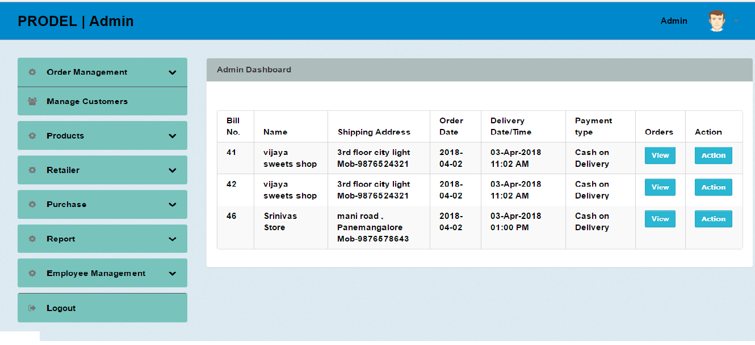

This is the home page of the admin.

**ORDER MANAGEMENT**

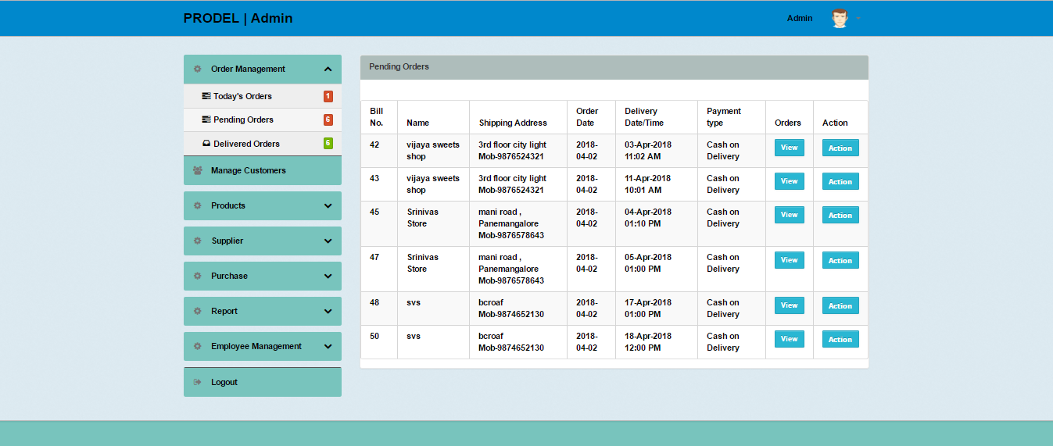

In this page purchase request from the customer i.e shopowner can be viewed. Later admin i.e distributor will deliver the products within the ordered date and time.

**MANAGE CUSTOMERS**

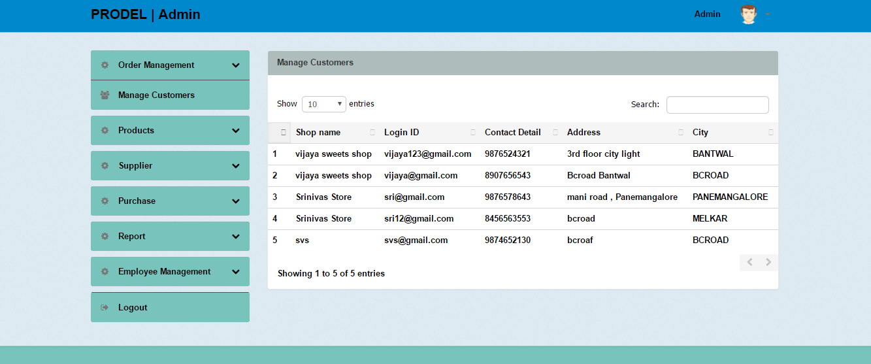

This page will display the customers address ,contact and city those who have logged in to the site.

**INSERT PRODUCTS**

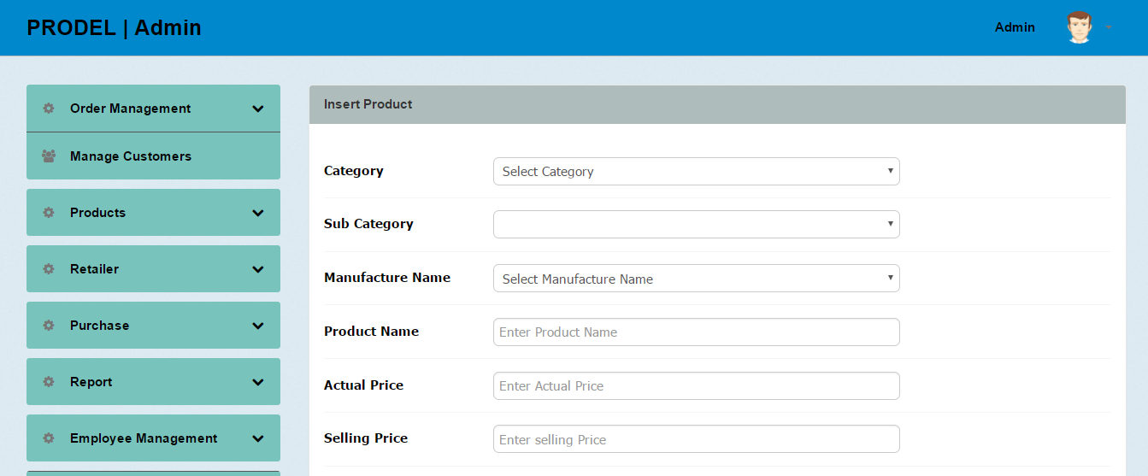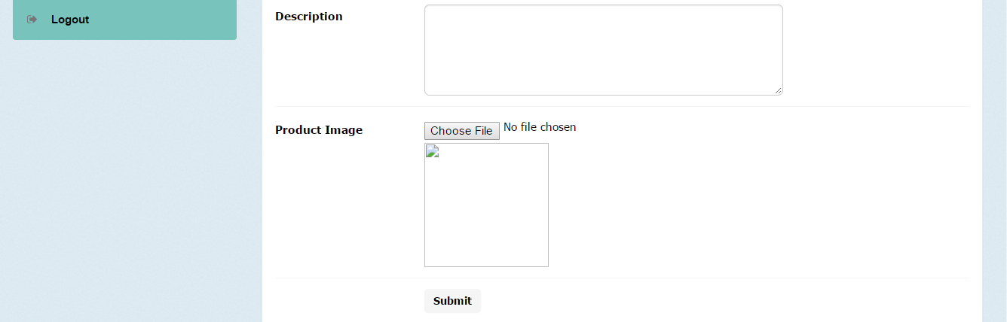

Admin has to insert the product name, category, subcategory, selling price and actual price for selling the products

**SUPPLIER**

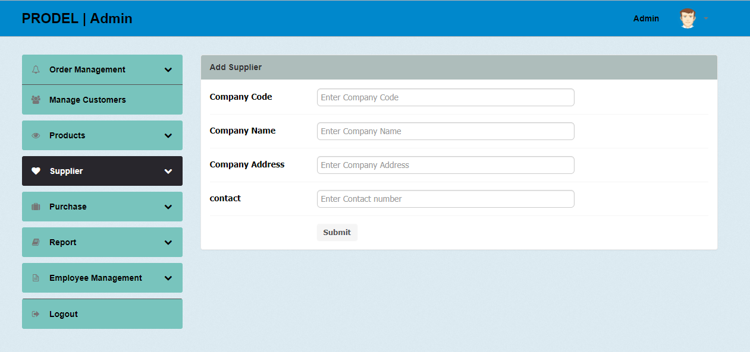

Admin has to add suppliler details.

**PURCHASE ENTRY**

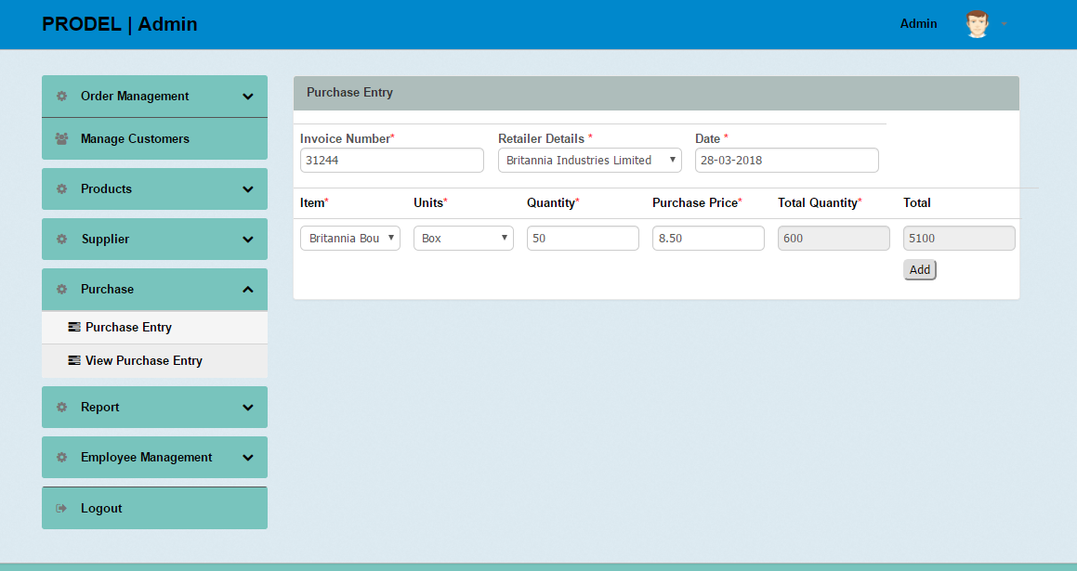

Admin has to add purchase entry to add the products for sales.

**REPORT**

**STOCK REPORT**

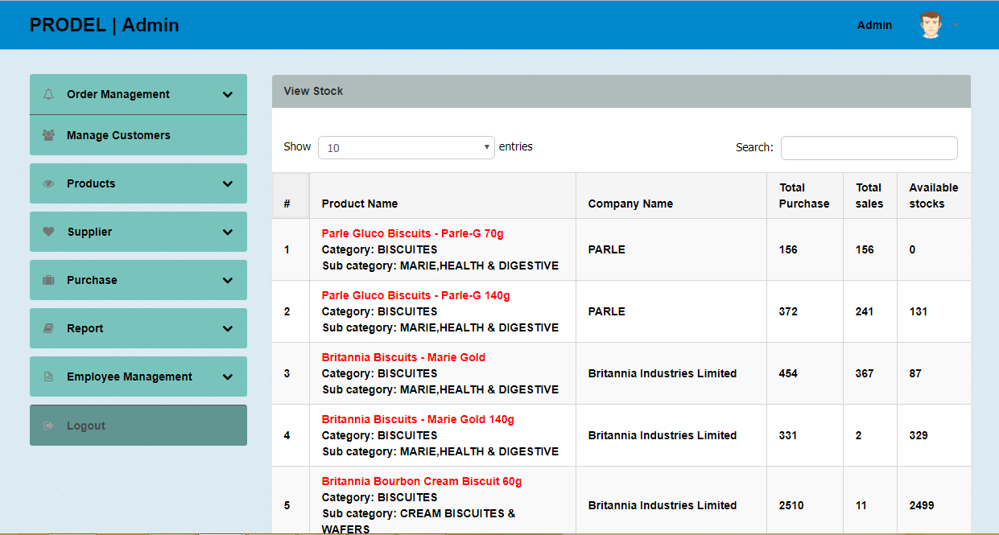

After each purchase and sales, the stocks of product are updated automatically.

**USER LOG**

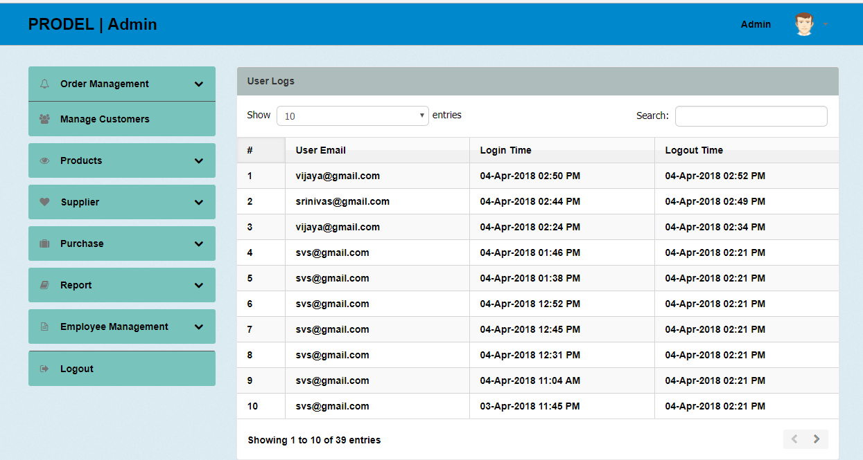

Admin can view login and logout session of the customer or shop owner.

**EMPLOYEE MANAGEMENT**

**ADD EMPLOYEE**

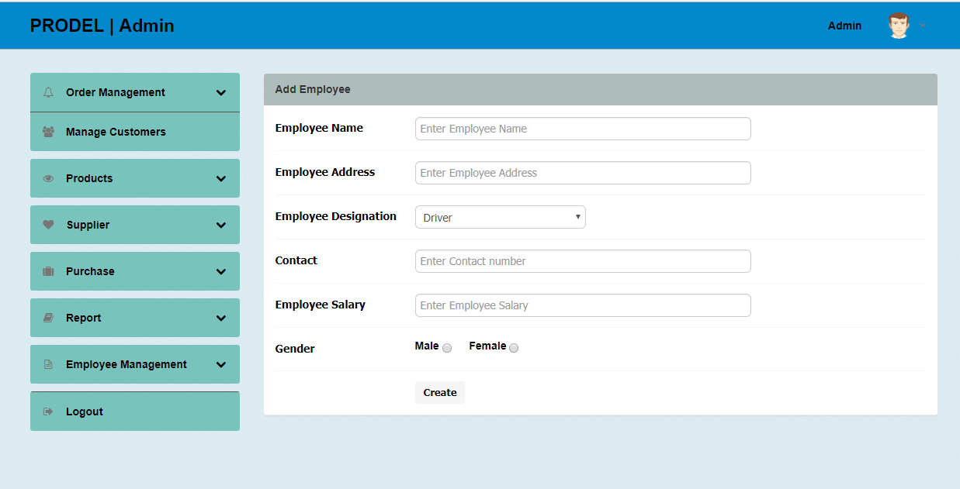

This is used to store the information about the Employees in the company. The information includes Name, address ,contact number,designation and gender.

**ADD ATTENDANCE**

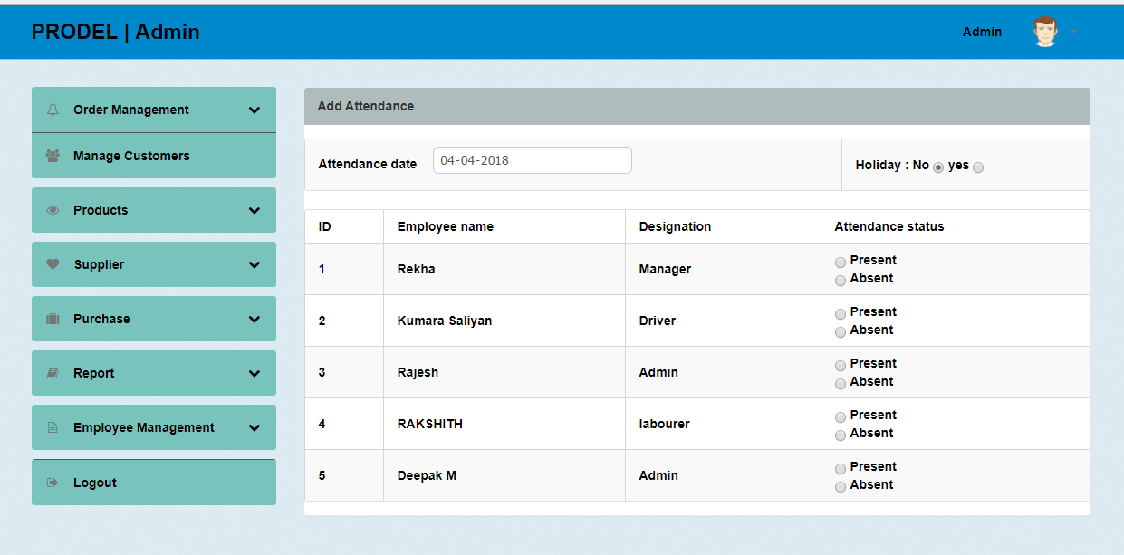

Attendance is taken for each employee daily.

**VIEW SALARY**

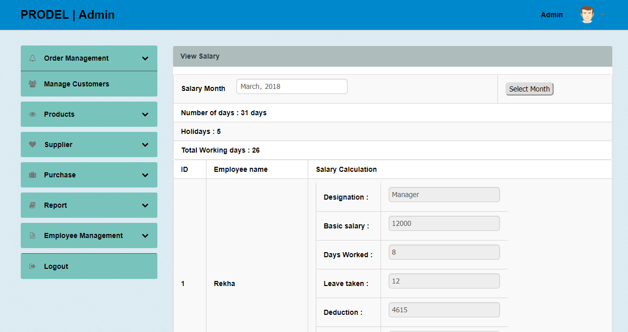

Details of the attendance generated for all the employees. Monthly salary can be viewed in this module for each employee.

**CUSTOMER MODULE**

**CUSTOMER LOGIN**

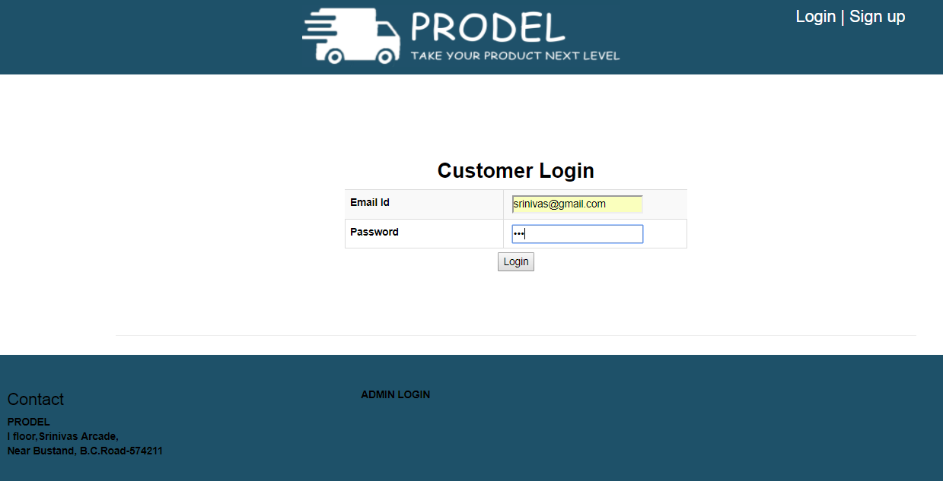

This is the customer Login page. Customer can Login by using username and password to purchase any products.

**HOME PAGE OF CUSTOMERS PAGE**

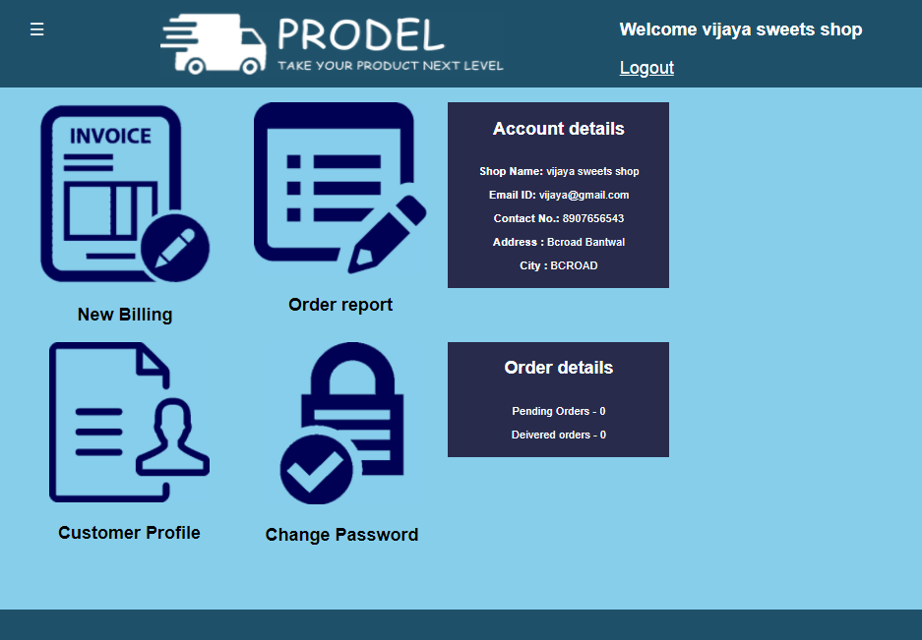

This is the home page of the Customers Page.

**NEW ORDER**

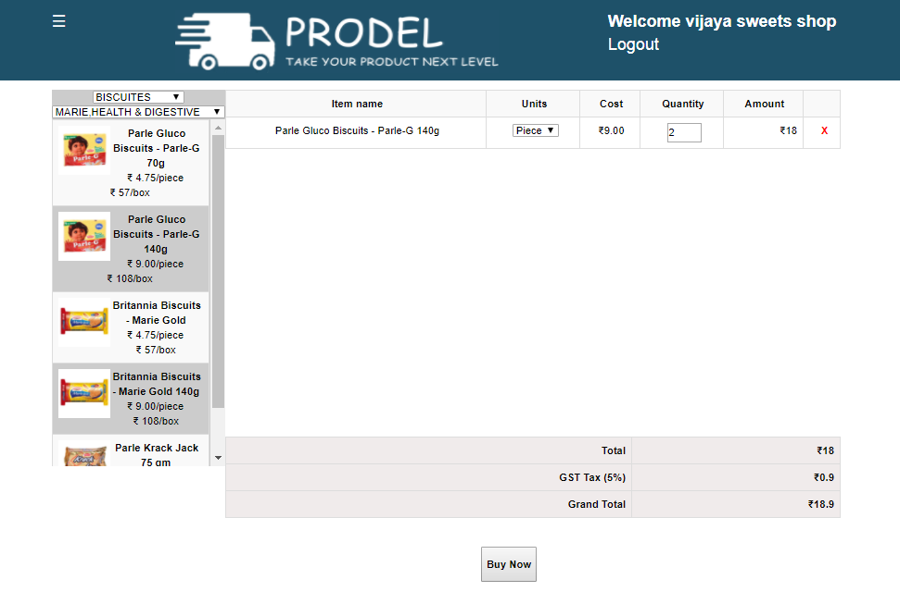

The user can purchase different products by category and subcategory. User has to enter unit of measurement and number of quantity to purchase the products.

**BILLING** 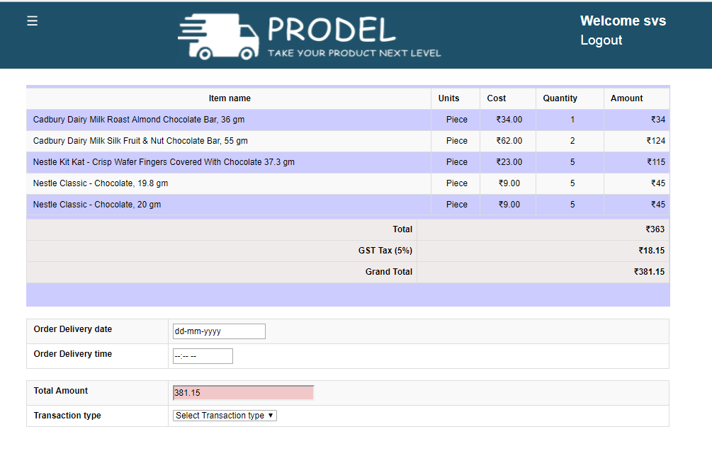

Purchase of any products can be done either by cash on delivery or by online payment. Customer has to enter date of delivery and time to order any products

**ORDER REPORT**

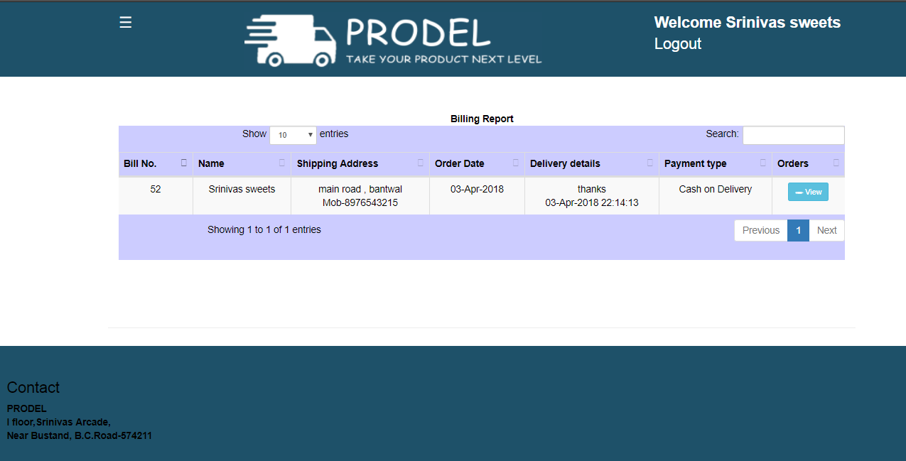

Previous purchase of the products and delivery status of any products can be viewd in this module.

**CUSTOMER PROFILE**

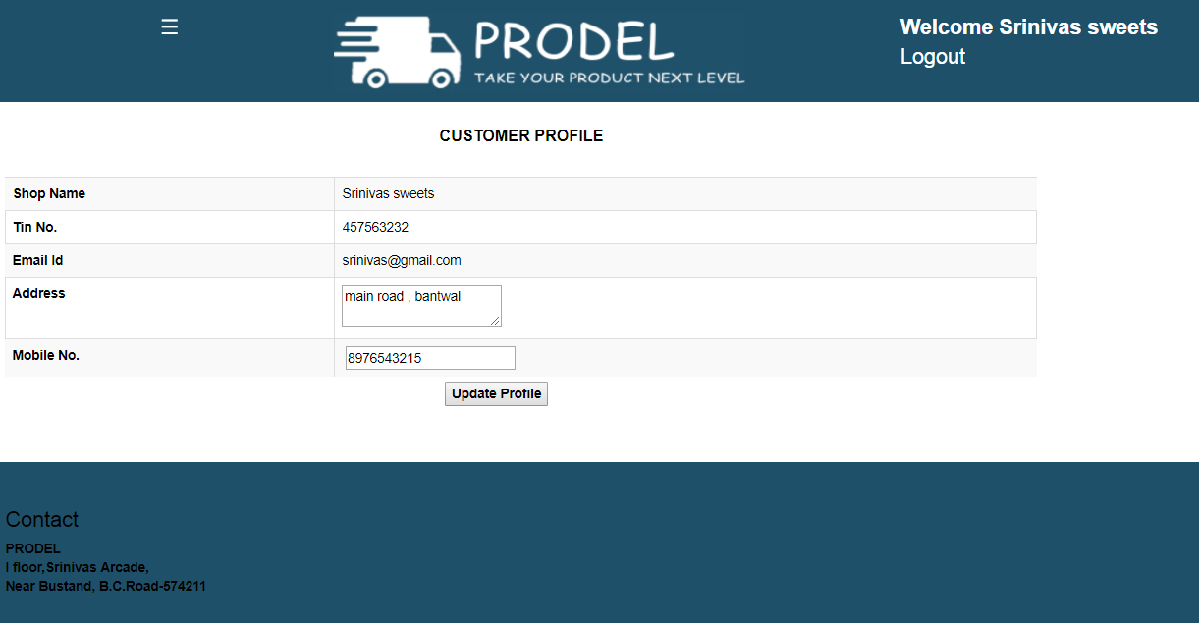

In this module customer profile can be modified. Fields such as contact and delivery can be updated by customer i.e. shop owner

**CHANGE PASSWORD**

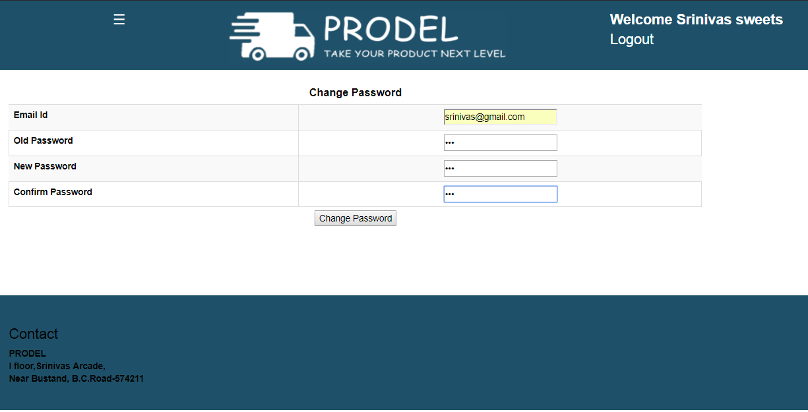

In this module shopowner or customer can change his password.

**USER MANUAL**

**7.USER MANUAL**

This manual describes the main function of the “**PRODEL**” Application and will give instructions on how the software works.

You will see that the terms click and double-click are used often in the manual. They mean the following:

* Click – means to press and release the left mouse button on the screen object which is indicated.
* Double click- means to click the left mouse button twice on the screen object. The two clicks should be made very quickly. Usually this action will open or close a window, activate a function, or finish a task.

Customer is the one who can visit the site and purchase the items which he wants. To purchase the products customer have to select the products from the list of categories and subcategory.After selecting he can change the quantity or customer can remove the items from cart. By clicking ‘Bill Now’ customer can select the way of payment .It can be online payment or cash on delivery. After delivering the products customer will receive the billing invoice